# Project resubmission notes

Branch : dev_feedback_0721

Repo : https://github.com/renjithkr-dev/image_processing_api.git

1. Made changes to the code so that error messages are returned if non-integer values are passed for width and height
2. Added new spec file “imageconversionSpec.ts” which tests the Image Conversion function. It will first delete the thumb if it exists, then evaluate the returned object to see if the width and height are as expected and also check if thumbnail is generated.
3. The endpoint url parameters and the sample url was already there in readme file. Attaching screenshot here.  
   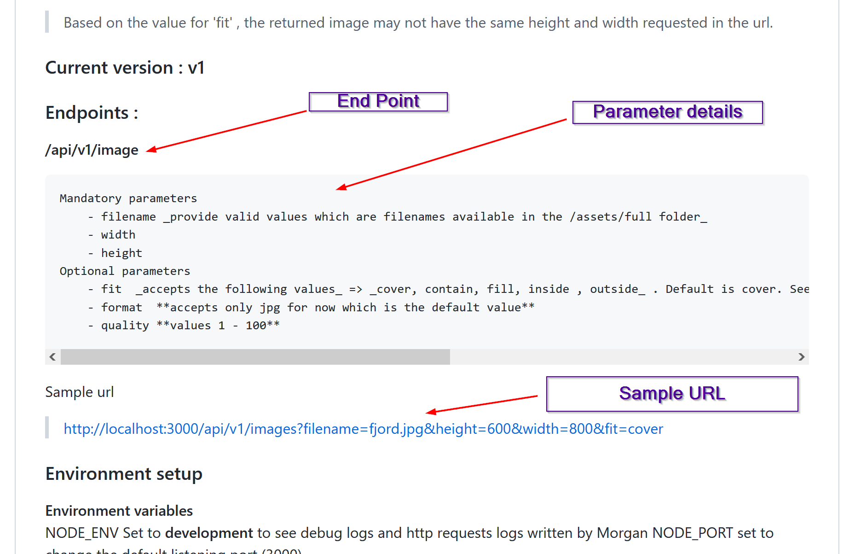
4. The details of scripts for both development and production were also already added in readme. Attaching screenshot for reference  
   Graphical user interface, application

   Description automatically generated